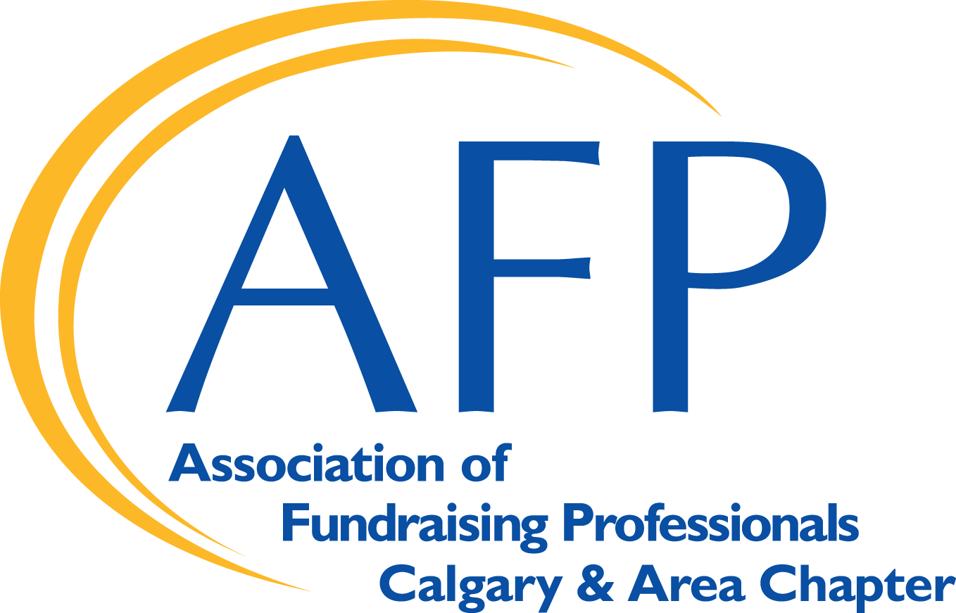
2024 Professional Awards
Outstanding New Fundraising Professional
AFP Calgary & Area Chapter

______________________________________________________________________

NOMINATION INFORMATION

Purpose: To annually recognize a newcomer to the fundraising profession (with 3 - 7 years of fundraising experience) who has made a significant contribution to the development of ethical fundraising in the region. The Honouree will be an individual who shows great promise in making a significant contribution to the profession and advancement of the work of philanthropy by supporting the AFP Mission.

AFP Mission: AFP, an association of professionals throughout the world, advances philanthropy by enabling people and organizations to practice ethical and effective fundraising. The core activities through which AFP fulfils this mission include education, training, mentoring, research, credentialing, and advocacy.

Honouree for 2024 Outstanding New Fundraising Professional
This achievement honours an outstanding individual who is relatively new to the fundraising profession. Nominations will be considered based on the responses to the following questions/criteria. Each question is graded from 0 (has not demonstrated proficiency in the category) to 100% (demonstrated exceptional credentials in the category). Narrative should contain complete, clear, and concise answers.

Nominations for this award may be placed by a supervisor of the nominee, an individual AFP member, an AFP Chapter or a community member who is not a member of AFP. Completeness of information is essential for consideration. Two letters of support are required for the nomination.

1) Summarize nominee’s fundraising career including role, organization, duration, and responsibilities.
These are paid – not volunteer – roles. (0 – 15 points) Please attach a copy of the Nominee’s resume.
2) Describe nominee’s length of fundraising career (maximum of seven years) and highlights of career
achievements including examples of surpassing goals, targets and/or objectives. (0 – 20 points)
3) Describe nominee’s short-term (present to five years) and long-term (five to ten years) career objectives.
(0 – 15 points)
4) Describe nominee’s involvement with AFP Calgary & Area Chapter. (0 – 10 points)
5) Describe nominee’s community involvement and investment including volunteer positions (annual time
and duration) and financial support to non-profit organizations. (0 – 15 points)
6) Describe any awards and honours nominee has received for his/her/their career or community work. (0 – 10
points)
7) Describe nominee’s commitment to professional development including fundraising conferences,
workshops and webinars. (0 – 15 points)
Selection Process
Entries will be judged on each of the criteria. The Honouree will be selected by a panel of judges comprised of members of the profession and the broader community. Because of the number of applications submitted, it is not possible to provide nominators with written evaluations of their entries. If, in the judgment of the judging panel, no applications meet the criteria, no Honouree will be selected.

Presentation & Celebration
The Honouree selected will be celebrated as part of National Philanthropy Day celebrations in Calgary. The Honouree must attend the National Philanthropy Day Luncheon scheduled for November 15, 2024 and must be willing to have biography, photos and videos prepared in advance of the NPD activities. The names of the other nominees will not be released or published.
DEADLINE: August 31, 2024, at midnight.
Please submit your nomination and all attachments (in pdf format) by email to: info@afpcalgary.com
If you do not receive email confirmation of receipt of your nomination, please call the AFP Calgary and Area office at (403) 297-1033.
.

2024 Philanthropy Awareness Week
Outstanding New Fundraising Professional
AFP Calgary & Area Chapter
______________________________________________________________________

NOMINATION FORM

Nominee Name: ________________________________________________________

Organization: _________________________________________________________

Address:_____________________________________________________________

City:____________________ Prov: ____________ Postal code: _________________

Email:__________________________________ Phone:________________________

Nomination Submitted by:

Nominator is:
Direct Supervisor
Other (please specify)

Nominator Name: _____________________________________________________

Organization: ________________________________________________________

Address:____________________________________________________________

City: __________________ Prov: ____________ Postal code: _________________

Email: _________________________________ Phone:______________________

Please check all the boxes that apply:
- In making this nomination, I have confirmed that the nominee is willing to allow their name to stand for this honour and the nominee has signed the nominee disclaimer. (Page 3)
- I have informed the nominee that the media may contact them for an interview.
- I have informed the nominee that they may be asked to participate in a video.
- I have informed the nominee that they may be asked to present at a Chapter event in 2023; to be set at a mutually convenient date and time.
- I have limited the nomination narrative to three pages (12-point font with 1” margins).
- I have enumerated each criterion and addressed each one separately in narrative form.
- I have included a quote from my nominee referencing the importance of philanthropy in the nominee’s life or community.
- I have included (in pdf format and emailed to the AFP Calgary and Area office, the full nomination package including the nomination form, narrative, quote from nominee (as outlined above), the nominee’s resume, and two letters of support.
- I am aware and have informed the nominee that the Honouree selected may be submitted for consideration for the corresponding AFP International Award.
- To the best of my knowledge, the applicant/nominee has not been involved with any unethical fundraising or criminal activity.
- I have confirmed with the nominee that he/she will be available for the National Philanthropy Day Luncheon scheduled for November 15, 2024
- I am aware the deadline for all documents is August 31, 2024 at midnight.

NOMINATION SUBMITTED BY:

Name:

Job Title:

Organization:

Address:

Tel: ___________________________ Fax: ___________________________

Email: ______________________________________________________

Nominator Signature: ________________________________________________

NOMINEE DISCLAIMER:

I _______________________ have read the above requirements and agree to let my name
(Nominee)

stand for nomination for the Outstanding New Fundraising Professional Award

____________________________________ ____________________________
Nominee Signature Date (Month/Day/Year)

Number of years in the Fundraising Profession: _____________

Current Position: ____________________________

Organization: _________________________

Address: _____________________________

_____________________________

Tel: ___________________________

Fax: ___________________________

Email: ______________________________________________________

